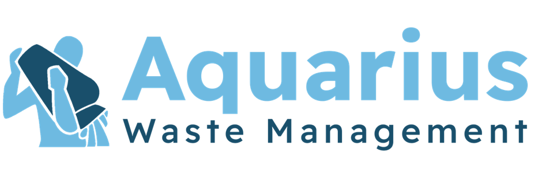

[Type a quote from the document or the summary of an interesting point. You can position the text box anywhere in the document. Use the Text Box Tools tab to change the formatting of the pull quote text box.]



*Customer:*

*Site:*

Method Statement For: Transport and Disposal of Liquid Gully waste via means of Vacuumation.

Purpose:

The purpose of the work to which this method statement applies is to carry out the Transport and Disposal of liquid waste via means of vacuum tanker.

Task:

1. On arrival operative(s) are to report to security and obtain necessary passes to enter site. All employees will book in as appropriate on arrival and when leaving site, to comply with client’s regulations.
2. Work permits and licences to be arranged (if required). If tools, equipment and materials are to be left on site at the end of a shift, the permission of the client’s agent will be obtained.
3. Protection of client’s assets, the client’s assets will be protected during the course of all work. The method for this will be detailed in a detailed site-specific method statement.
4. To carry out an assessment of the work area and to cone of the work area, provide signing, and guarding as necessary.
5. Fire Evacuation procedures will be carried out as per site or client’s instructions.
6. All operators will be issued with and trained in the use of the following PPE:

* Minimum requirement: Overalls, gloves, hard hats, safety boots, Hi Vis Jackets, Safety glasses.
* Specific: Full face visor, ear defender, wetsuit, safety boots.

1. Operative(s) must work with a full regard to their own Health and Safety and to the Health and Safety of others, and to be aware of the customer’s own Health and Safety and emergency procedures.
2. Air quality and dust all equipment will be regularly maintained with specific attention being given to control of exhaust emissions.
3. Vacuum tankers the necessary equipment and hoses to be removed from the vehicle, ensuring that there is sufficient number of hoses to safely reach from the vacuum pump (when connected), to the work area.
4. The liquid is pumped out removing as much sludge and debris as possible, and any that is resistant, to be removed with the aid of on board wash down equipment.
5. All vacuumation equipment will be regularly maintained and serviced and will satisfy statutory requirements for noise and air emissions.
6. Should the operative have cause to leave the work area for any reason during the operation, all the covers are to be replaced, and the site left in a secure and safe order.
7. When the work has been completed to the customer’s satisfaction, the operative is to record the work carried out and if any the volume removed together with the time taken and a signature obtained from the customer or his/her representative.
8. On completion of any empty all manhole covers will be replaced. All the equipment to be safely stowed on the vehicle, all connections to be checked to avoid any spillage during transit. The work area to be left clean and tidy.
9. Good housekeeping all working areas on all sites will be left clean, tidy, clear of any obstruction and safe on completion of works.
10. Any damage noticed at time of collection must be reported to site contact.
11. All waste will be removed from site and disposed of to a licensed waste transfer station or waste disposal site as listed below. Aquarius Waste Management Ltd will provide all relevant EA Notes as required. All such activities are carried out in accordance with the requirements of the Code of practice under the provision of the environment protection act 1990. Aquarius Waste Management Ltd is a licensed waste carrier and its registration no. Is CBDU173726.

Accidents/Incidents

1. Accidents, incidents and reporting of injuries, diseases and dangerous occurrences (RIDDOR 2013)

* All accidents will be recorded in the accident book (Form IR1, Near Miss Report and reported to the client.
* Incidents that are reportable, under RIDDOR 2013 will be reported to the HSE using forms IR1, IR2, F2508A etc. Copies will be sent to the client.
* The site safety file ill contain a site-specific accident book, although all information entered will be recorded in the depot accident book.

EMERGENCY PROCEDURE

Aquarius Waste Management Ltd: 24 hour Emergency Services Number is:

* + Telephone 01179 869815 (In hours 8am – 4pm) or
  + 07921 226095 (out of hours)
  + E-Mail: [info@aquariuswaste.co.uk](mailto:info@aquariuswaste.co.uk)

1. All records, documentation and all consents, environmental checklist and audit results are kept at our head office. These are the responsibility of Andy Gunton who can be contacted on 01179 869815.
2. For Inspection and environmental auditing please contact the office on 01179869815
3. Systems and codes of practice a schedule of documents and references is included in the appendices of the method statements. This list is not exhaustive and a check should be made for any revisions.